Advanced Reporting Concepts
1. Row-Level Security (RLS) was implemented in the Sales Performance Dashboard (PowerBILab1) using two distinct patterns:
- Static RLS was applied to Sales Territories (North America, Europe, Pacific), as these represent stable, structural organizational boundaries. Since regional roles are fixed and non-overlapping, user management is handled entirely within the Power BI Service without requiring data model updates.
- Dynamic RLS was deployed for Product Categories (Bikes, Clothing, Accessories, Components) to accommodate fluid, individual assignments that change as business roles evolve.
Static RLS
To secure geographic regions with stable organizational boundaries, a Static RLS pattern was implemented. This approach defines explicit roles with fixed rules directly inside Power BI Desktop.
Via the Modeling tab - Manage roles, the "Manage security roles" dialog was opened. A new role named North America was created.
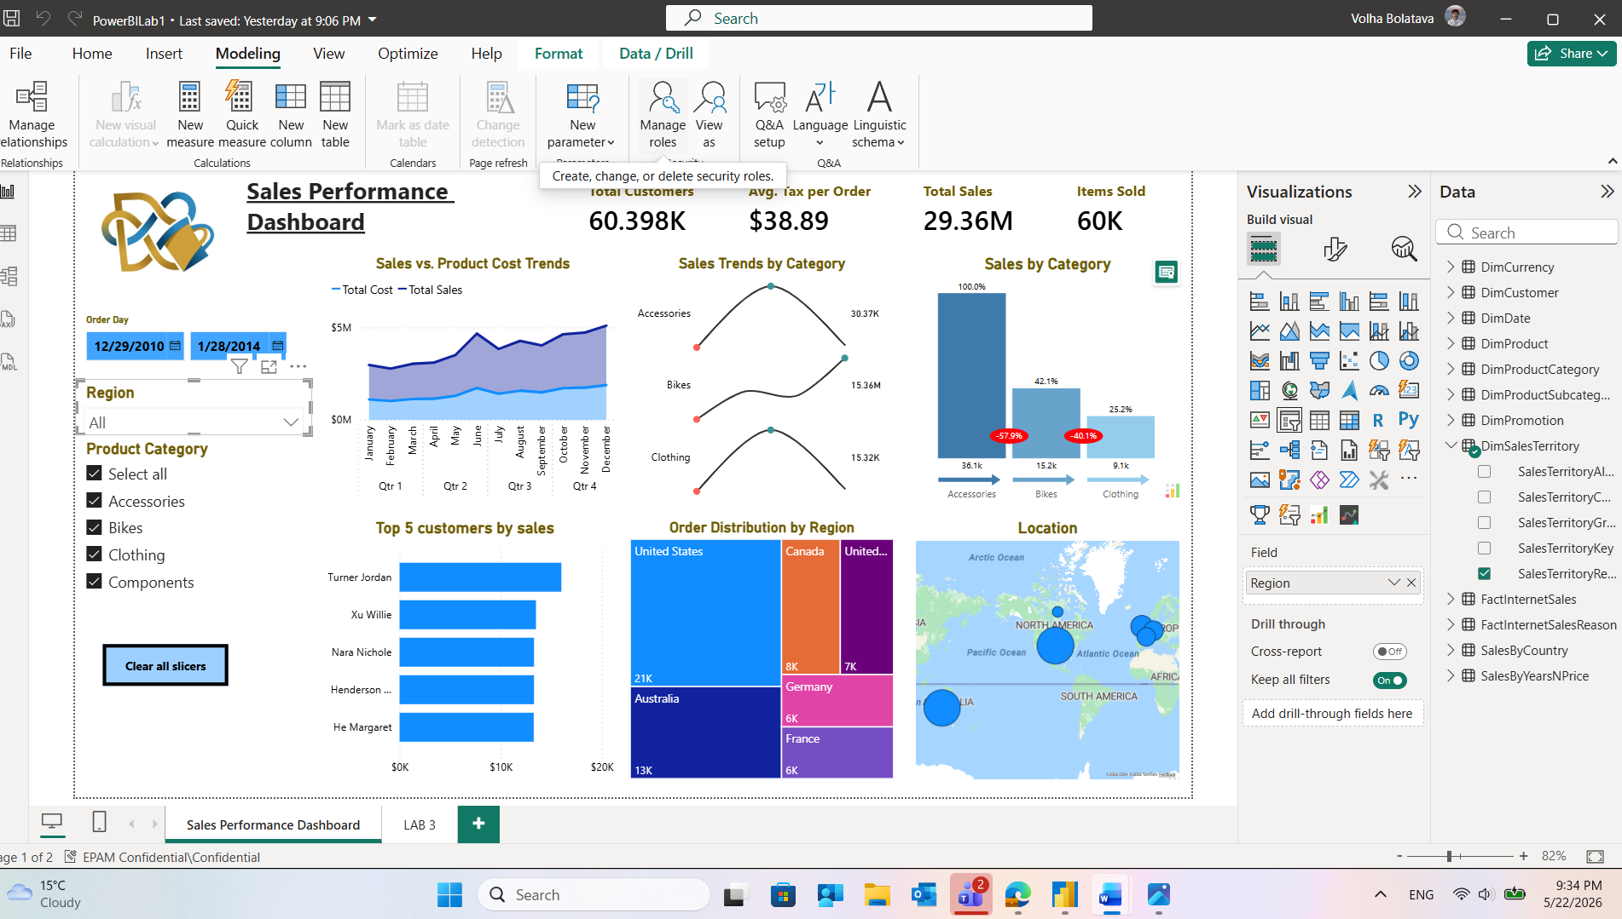
Fixed security roles were built to match the predefined geographical boundaries of the company’s sales hierarchy. Separate roles were created for each target region: North America, Europe, and Pacific. For each role, a rule was applied to the DimSalesTerritory table using the default visual editor. The column SalesTerritoryGroup was configured with the condition Equals and assigned the corresponding literal text value (e.g., North America for the North America role, Pacific for the Pacific role):
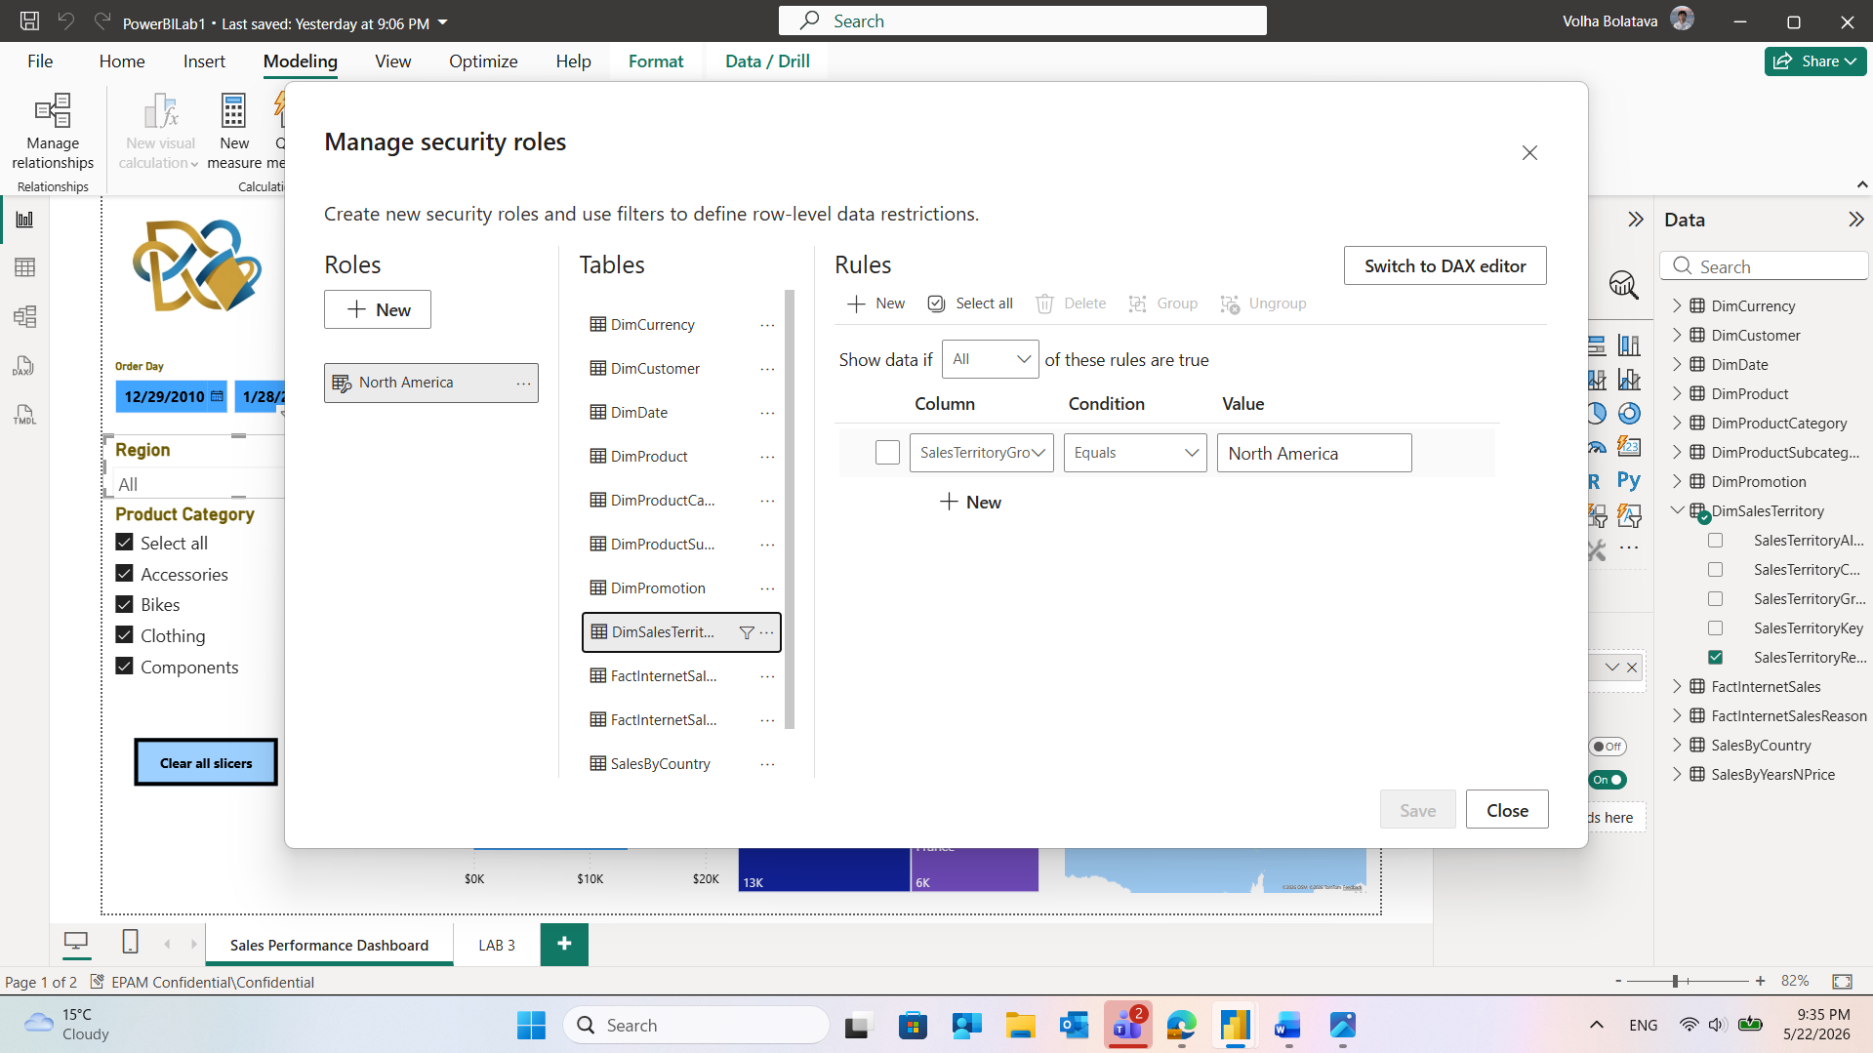
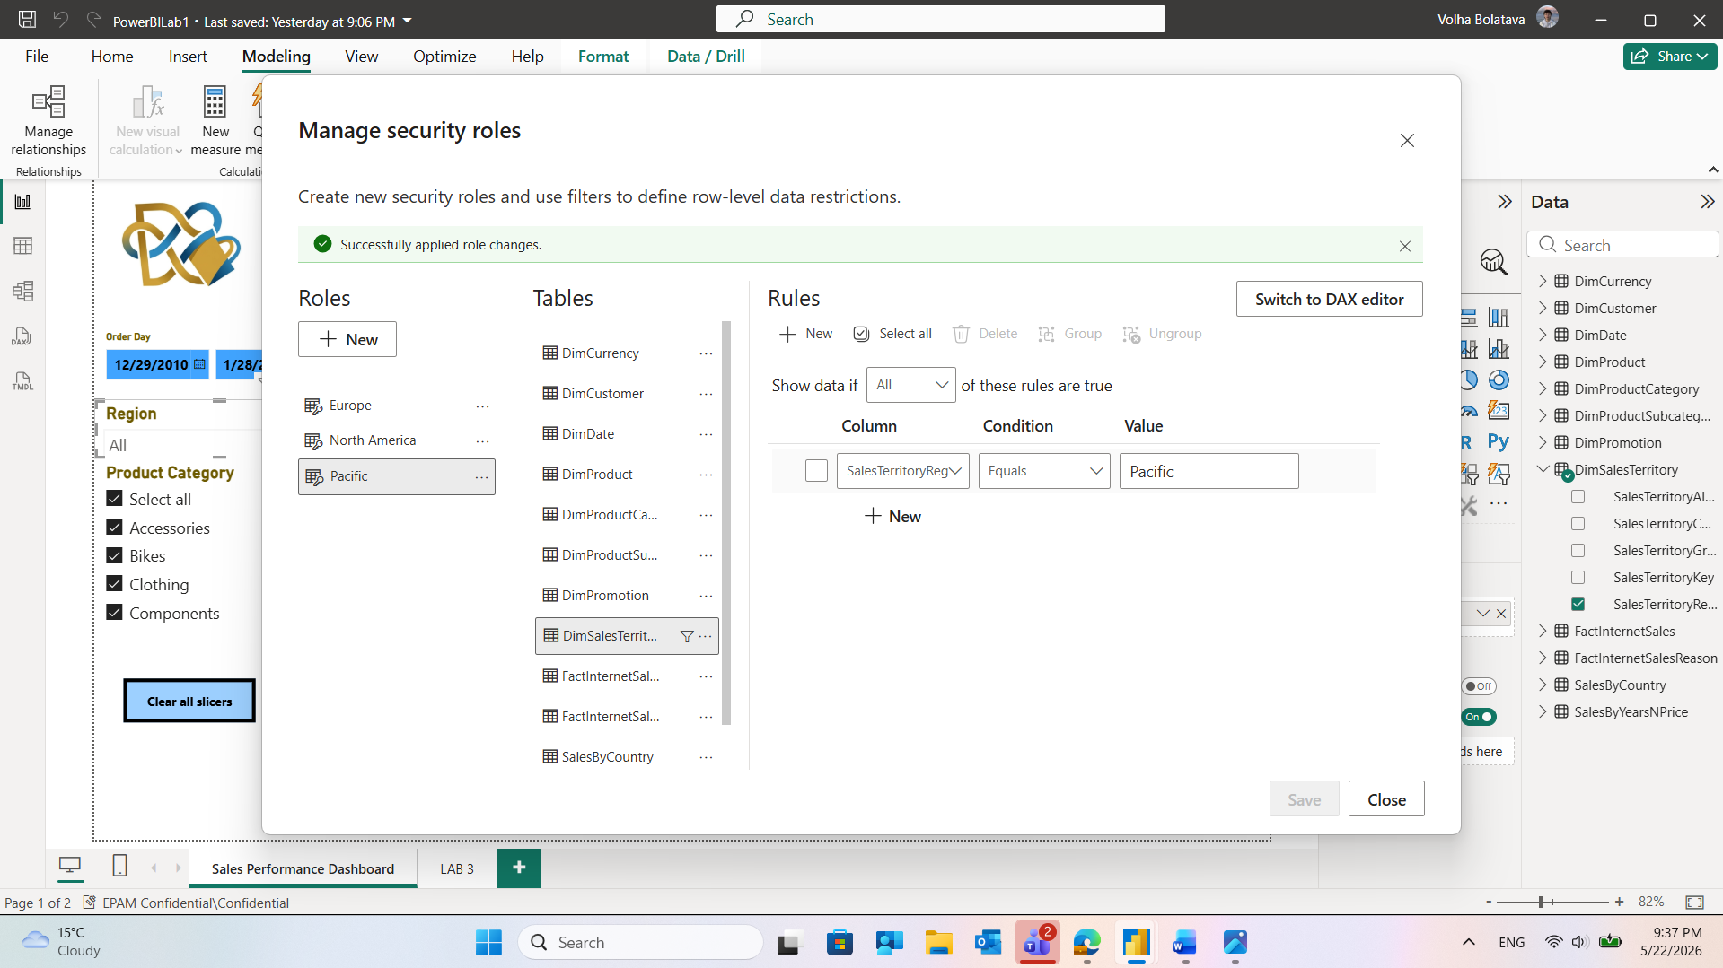
Each defined territory role was individually tested by checking its respective box in the View as roles dialog panel. The resulting data segregation was validated across three distinct states:
- North America Validation: Activating the North America role updated the viewing context indicator bar. The dashboard successfully isolated data metrics, restricting the Order Distribution by Region map and tree charts strictly to data from the United States and Canada, dropping total sales visibility down to $\$28.96\text{K}$.
- Europe Validation: Activating the Europe role constrained visibility strictly to European countries (such as the United Kingdom, Germany, and France), adjusting the visible KPIs accordingly to show an isolated sales volume of $\$18.09\text{K}$.
- Pacific Validation: Activating the Pacific role completely filtered out all western territories, updating the geographical layout to focus strictly on Australia with its respective sales performance metrics ($\$13.345\text{K}$).
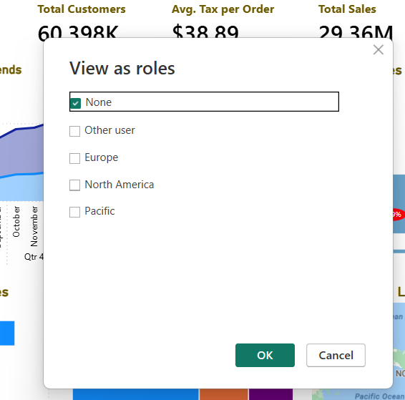
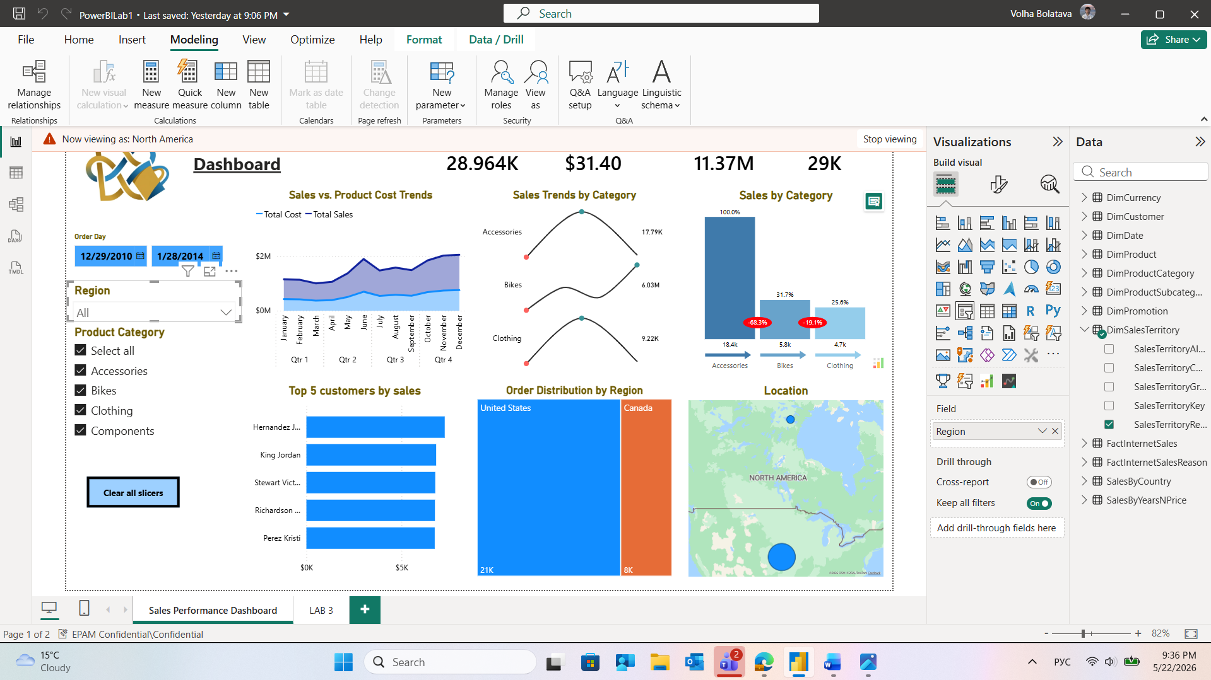
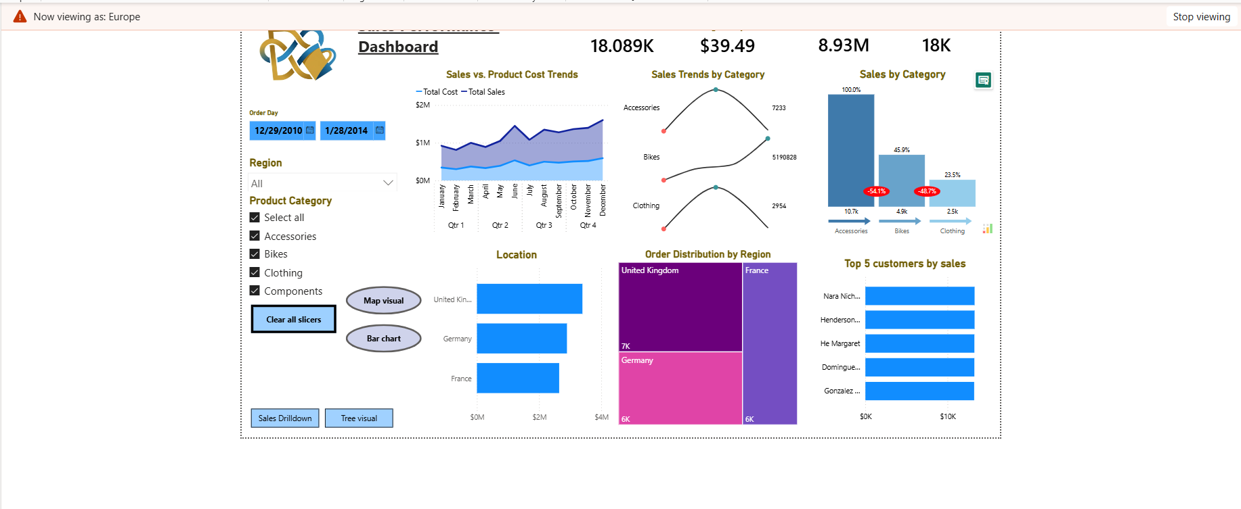
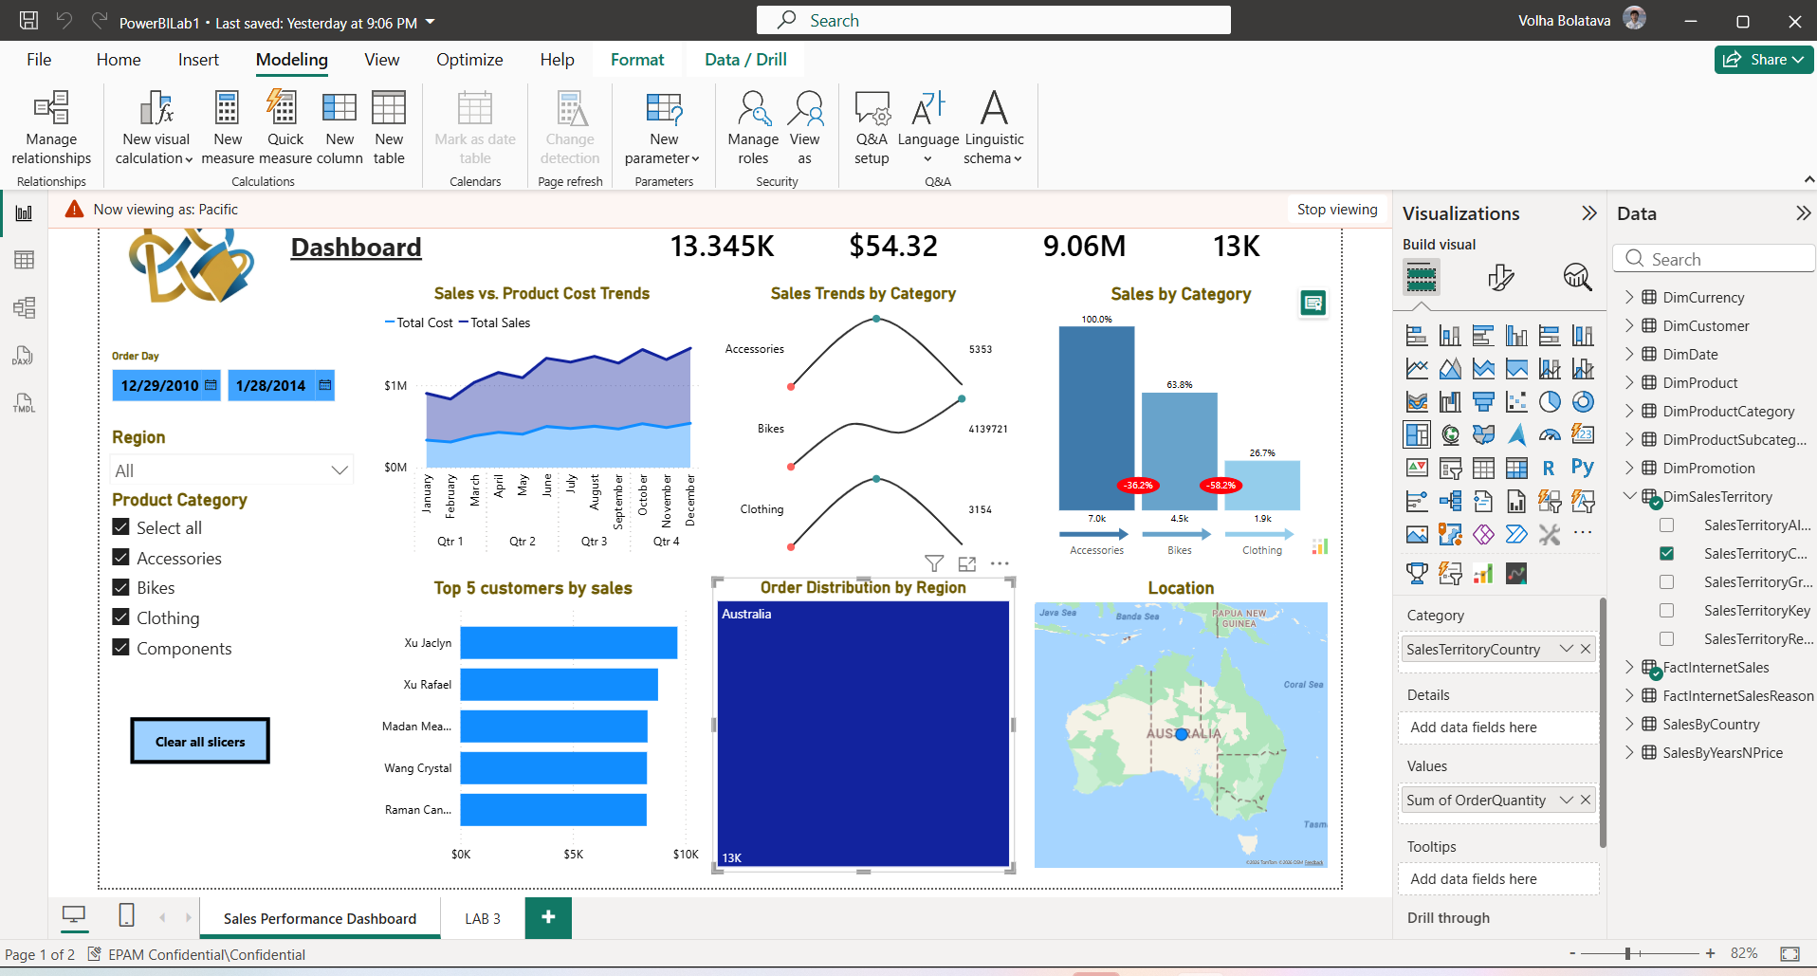
This comprehensive phase confirms that the static boundaries are properly implemented. New regional employees can be mapped directly to these ready-made Power BI Service roles without changing the dashboard's design.
Dynamic RLS
To implement fluid, user-based filtering for product categories, a Dynamic RLS pattern was deployed. A dedicated mapping table named Dynamic RLS was created within the data model to link user identities with their specific data permissions.This table contains two main columns: Category (Product Categories) and Reporter (User Principal Names / Email Addresses).Unlike Static RLS, which relies on fixed definitions, this mapping table allows the organization to assign multiple, evolving combinations of categories to different users:
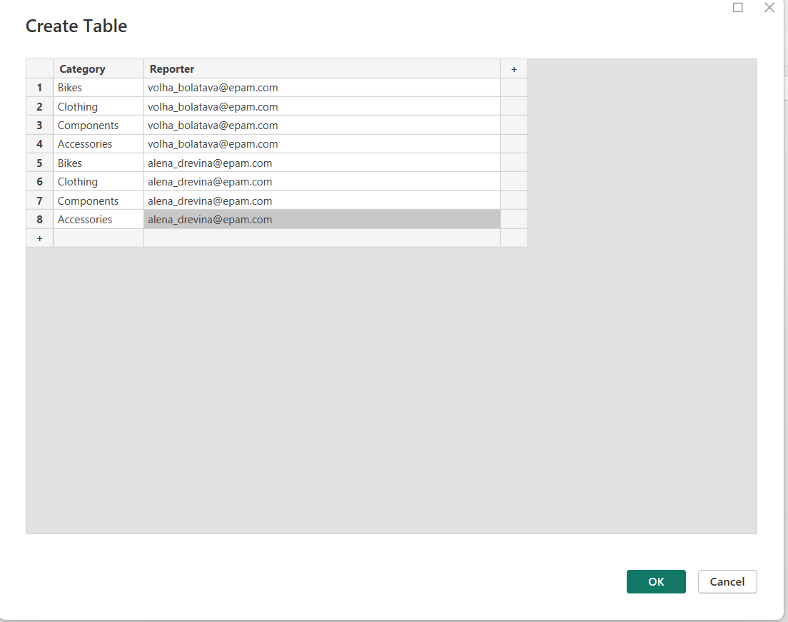
To ensure that the security filters propagate correctly to the rest of the report, a relationship was established between the Dynamic RLS mapping table and the main dimension table, DimProductCategory. Many-to-many (*:*) — chosen because a single user can manage multiple categories, and a single category can be managed by multiple users. The option "Apply security filter in both directions" was explicitly enabled. Enabling the bidirectional security filter ensures that when the Dynamic RLS table is filtered down to a specific user's email, that filter automatically flows upstream to restrict the rows in DimProductCategory, which subsequently filters all related fact tables
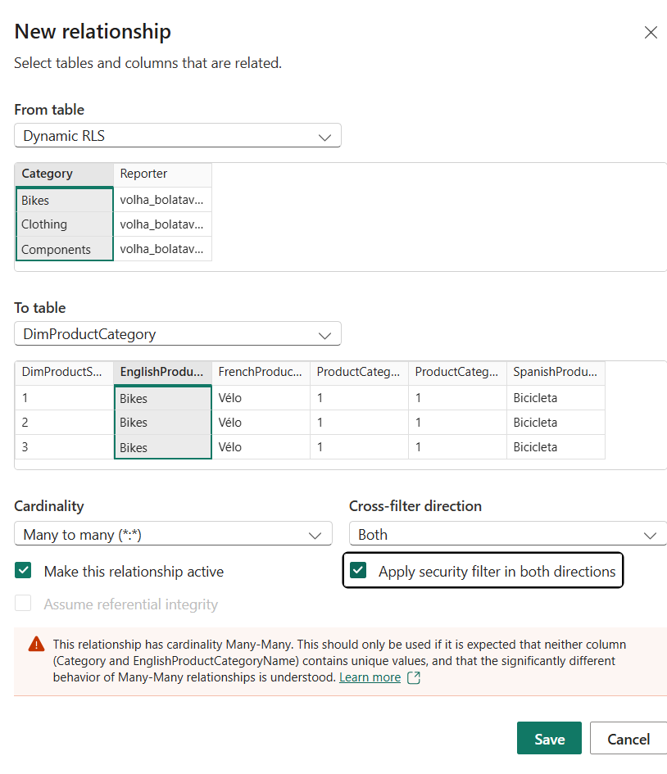
A dynamic role was defined in Power BI Desktop using the Manage security roles interface. The USERPRINCIPALNAME() function is a dynamic DAX routine that automatically captures the login email address of the active user currently viewing the report in Power BI Service. This single DAX rule dynamically filters the Reporter column to match only the current user's email, eliminating the need to hardcode individual user permissions into the report:
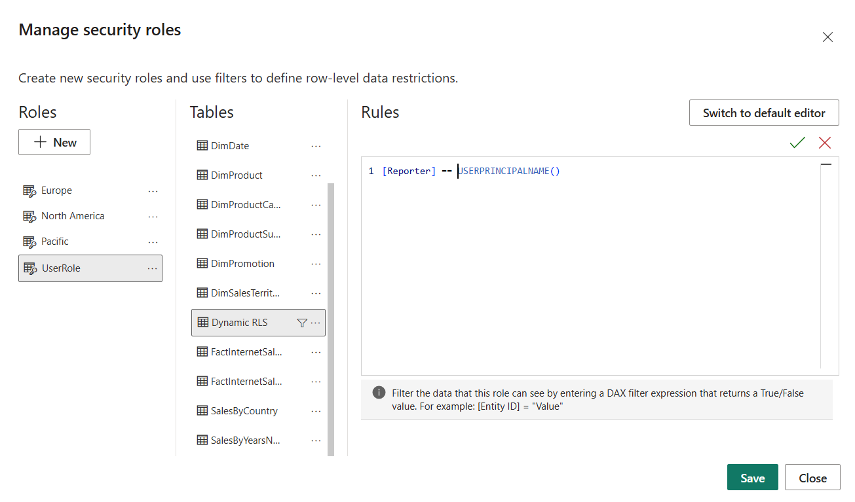
Before publishing to the Power BI Service, the security configuration was thoroughly validated using the View as roles feature. The report was tested by selecting "Other user" and entering a specific tester's identity (e.g., alena_drevina@epam.com), while simultaneously checking the UserRole checkbox:
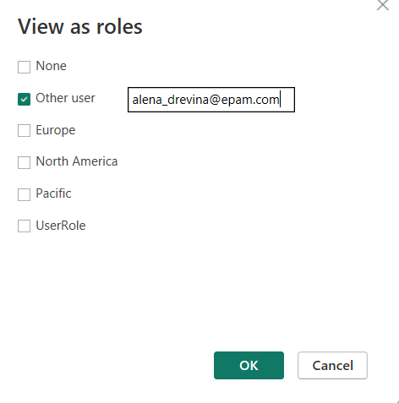
The dashboard successfully refreshed and entered the simulated viewing environment ("Now viewing as: alena_drevina@epam.com"). The slicers and all visuals automatically filtered down to display data exclusively for the product categories assigned to that user in the mapping table, confirming that the dynamic row-level access control works seamlessly and securely:
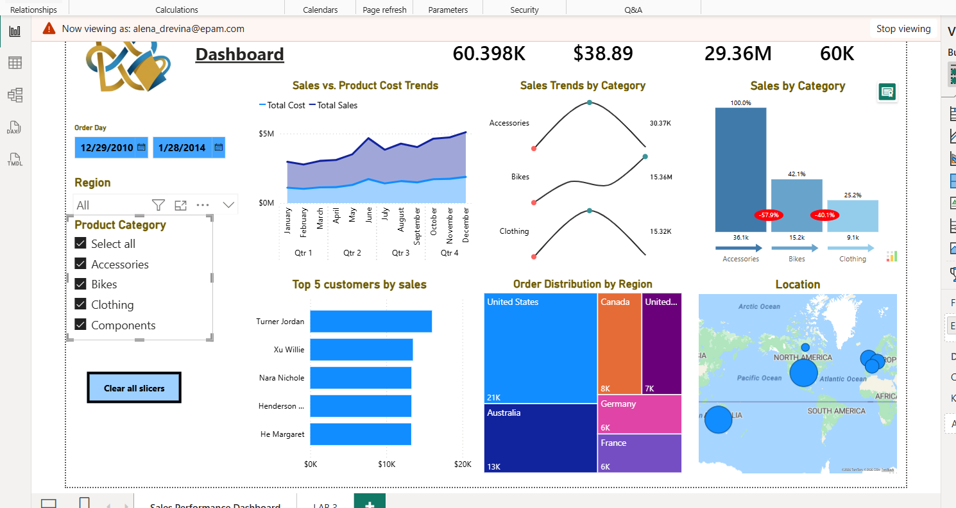
After defining and testing the static and dynamic security boundaries locally in Power BI Desktop, the configuration must be published to the cloud and mapped to organizational accounts to activate cloud-hosted security enforcement.
The completed data model, visuals, and background security rules were compiled and transferred to the cloud workspace:
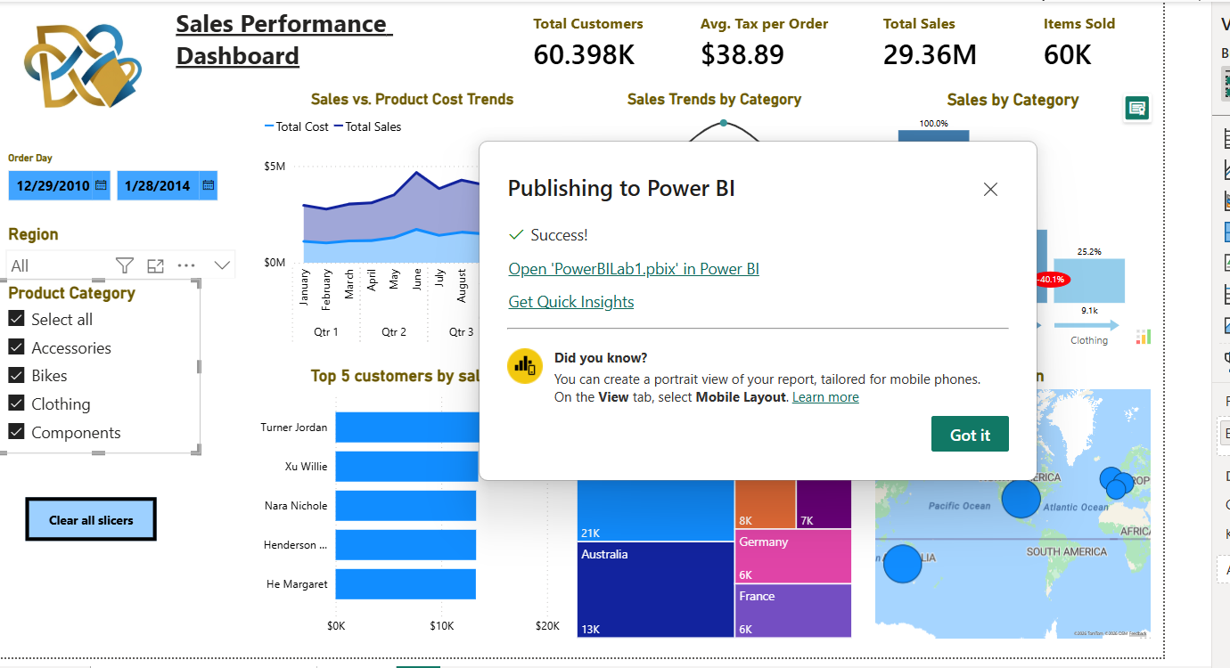
Once published, user permissions must be assigned at the semantic model level, not the report layout level. Within the Power BI Service workspace, the options context menu (...) for the published PowerBILab1 semantic model was opened, and Security was selected:
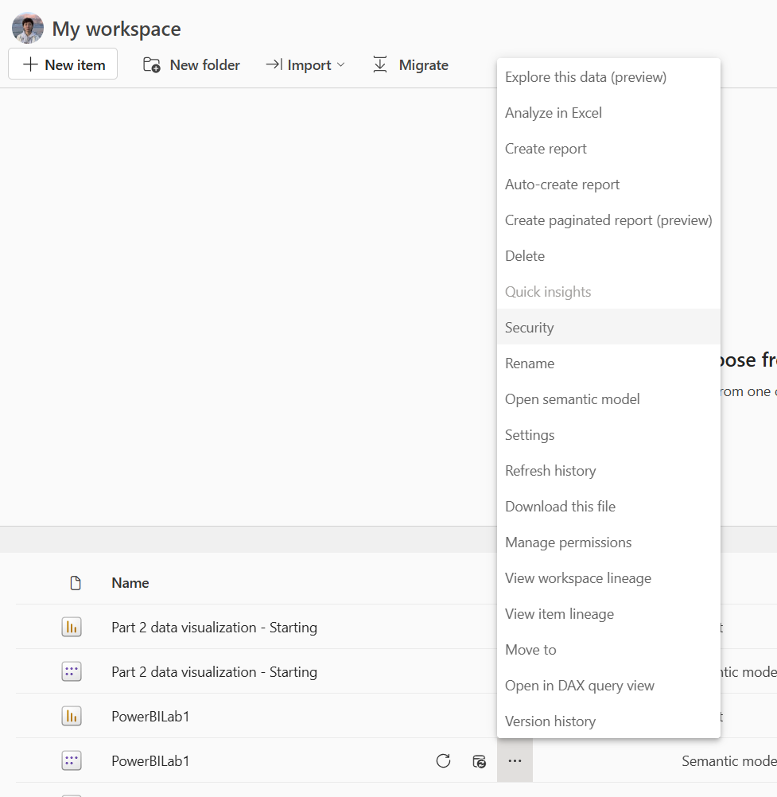
Corporate identities were mapped to both the structural (Static) and mapping-table-driven (Dynamic) roles. Under the Row-Level Security interface, individual technical users and stakeholders (e.g., Alena Drevina and Volha Bolatava) were added directly into the member list of the target roles, such as the dynamic UserRole and regional static roles
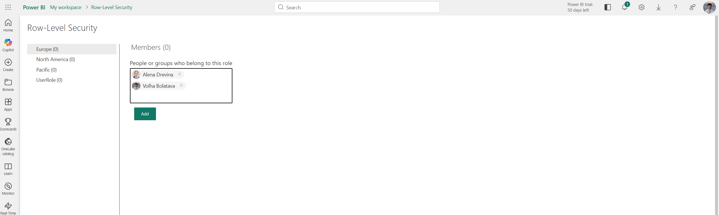
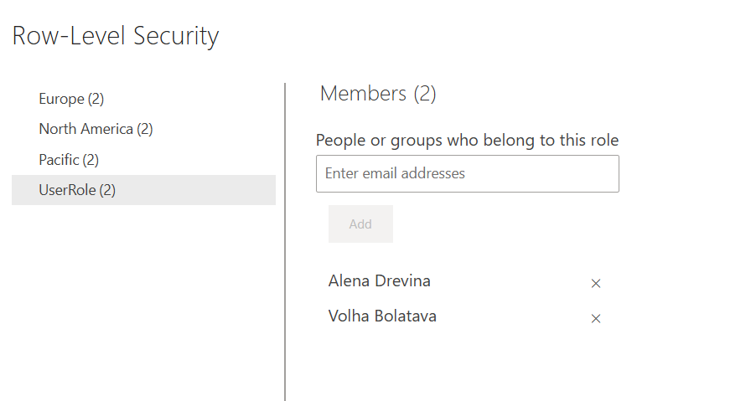
This bridges corporate directory identities with the model logic. For Static RLS, it seals which users belong to specific fixed roles. For Dynamic RLS, it ensures that when these specific accounts log in, their matching identity strings are captured effectively by the underlying DAX logic.
To guarantee that security rules execute flawlessly for final consumers, cloud simulation was used to validate the active workspace directory filters. Hovering over a role (e.g., Europe) in the cloud interface, the context option "Test as role" was selected:
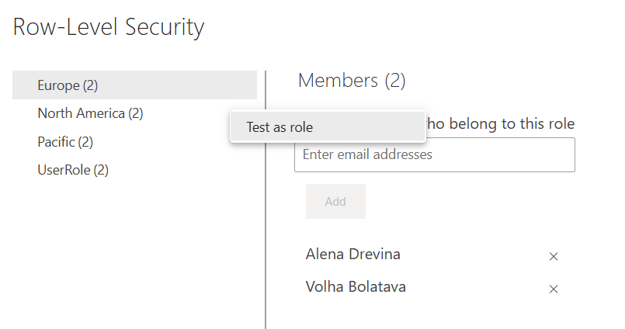
This shifts the Power BI Service preview into a live security simulation framework ("Now viewing as: Europe"), reflecting exactly what a member mapped to that role would encounter.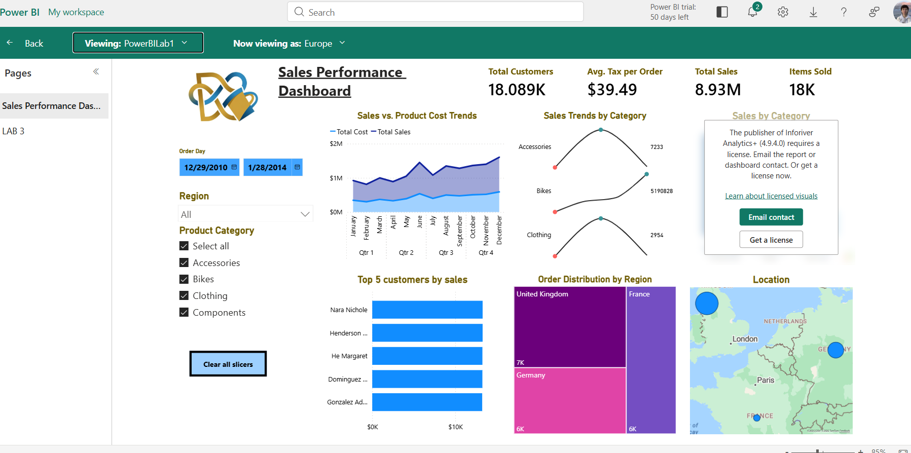
Visibility was restricted exclusively to European sales data (displaying total sales of $18.089K and isolating regional map pointers to the UK, France, and Germany), successfully confirming that both data tier segregation and cloud access constraints function flawlessly in production.
2. To optimize dashboard real estate and provide interactive data exploration, a layout switching mechanism was built. This allows users to dynamically switch between a Bar Chart and a Map Visual overlapping in the exact same workspace area.
Before capturing states, the two core target visuals were built and positioned on the canvas. Both the Location map and the Location bar chart were overlayed directly on top of each other in the bottom-middle section of the dashboard canvas. Also 2 buttons were added to the dashboard:
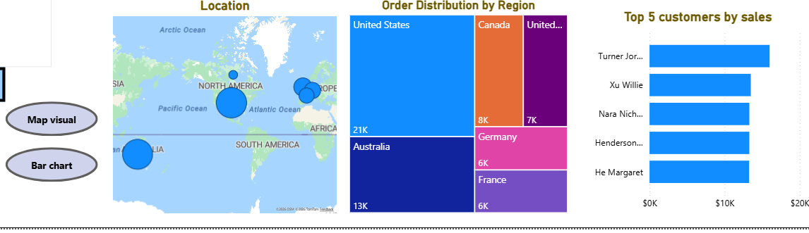
The Selection pane was activated under the View ribbon. The two visuals were isolated alongside the navigation elements: Map visual (button), Bar chart (button), Location (Map visual), and Location (Bar chart visual):
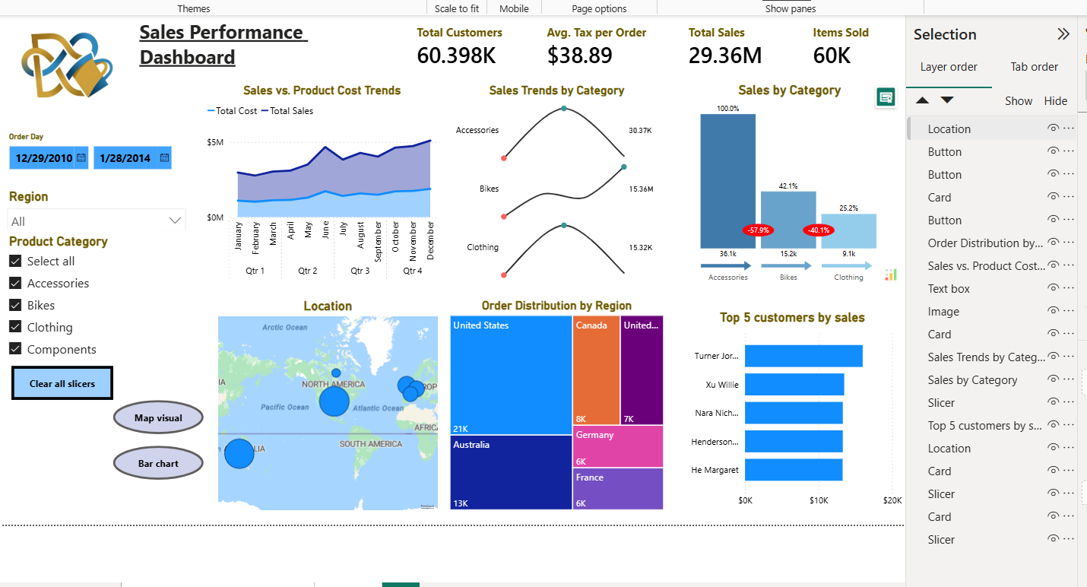
With the canvas visibility configured for each layout alternative, specific report snapshots were saved in the Bookmarks pane. The map visual was hidden using the selection eye icon, leaving only the bar chart visible. A bookmark named Bar chart was added. Crucially, the configuration properties were optimized: Data was unchecked, while Display, Page, and Selected visuals remained enabled. Unchecking the Data property ensures that clicking these toggle buttons changes only the visual layout on screen, without accidentally resetting or overriding any active slicer filters (like dates or categories) chosen by the end user.
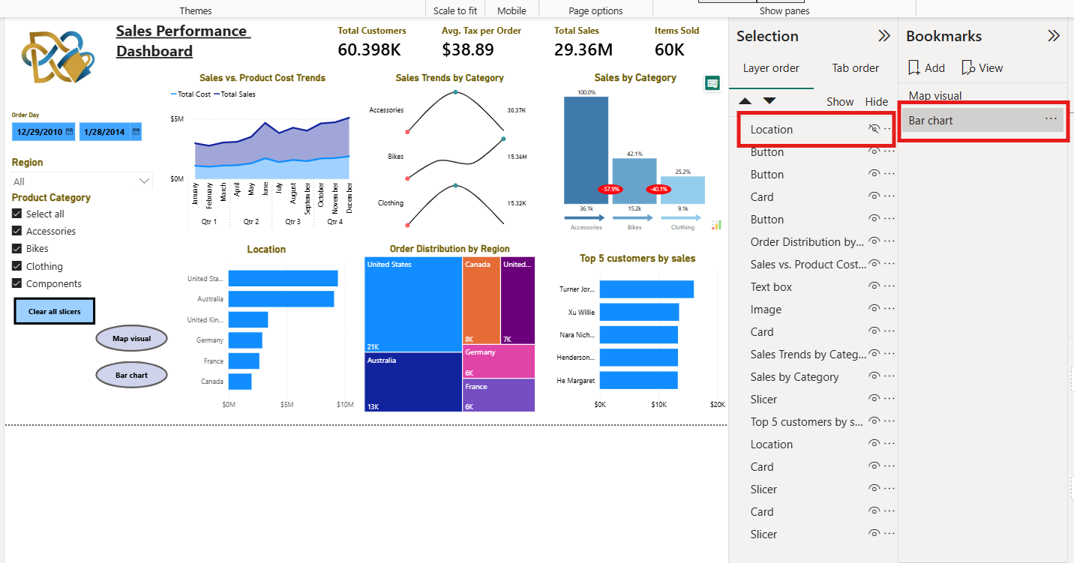
The visibility was reversed—the bar chart visual was hidden, and the map layout was unhidden. A second bookmark named Map was saved with the same property adjustments.
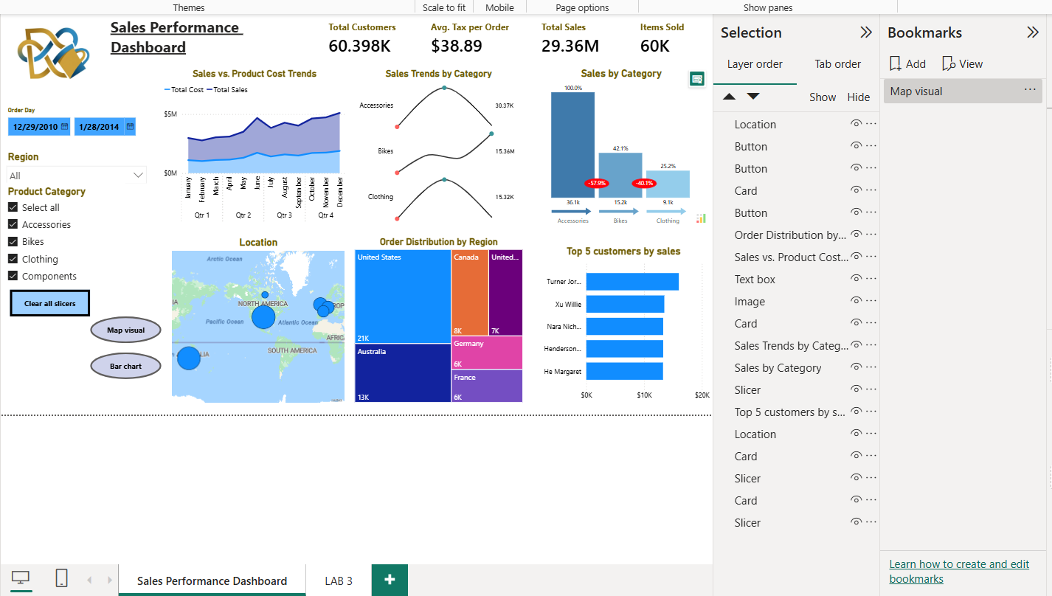
Two clear, clickable navigator elements (Map visual and Bar chart) were designed on the report canvas to drive the interface. Each button was selected individually, and its properties were modified in the Format pane. This converts flat graphical buttons into dynamic UI triggers, allowing an end user to interactively click and shift between geospatial and categorical data representations seamlessly.
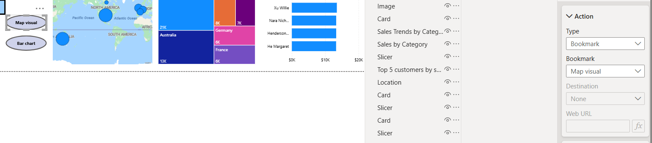
As part of the Sales Performance Dashboard optimization, dynamic button highlighting was successfully implemented using the Bookmark Navigator. This approach ensures that the active state for the "Map visual" and "Bar chart" views is clearly visible, significantly improving user experience and UI intuitiveness without cluttering the report's structure.
A dynamic layout toggle was successfully implemented using synchronized Bookmarks, the Selection pane, and button Bookmark. By strategically unticking the Data setting on the bookmarks, users can fluidly switch between a full-scale geographic map representation and a detailed horizontal bar chart in the same dashboard zone. This implementation optimizes report space while preserving all active runtime slicer selections.
The result:
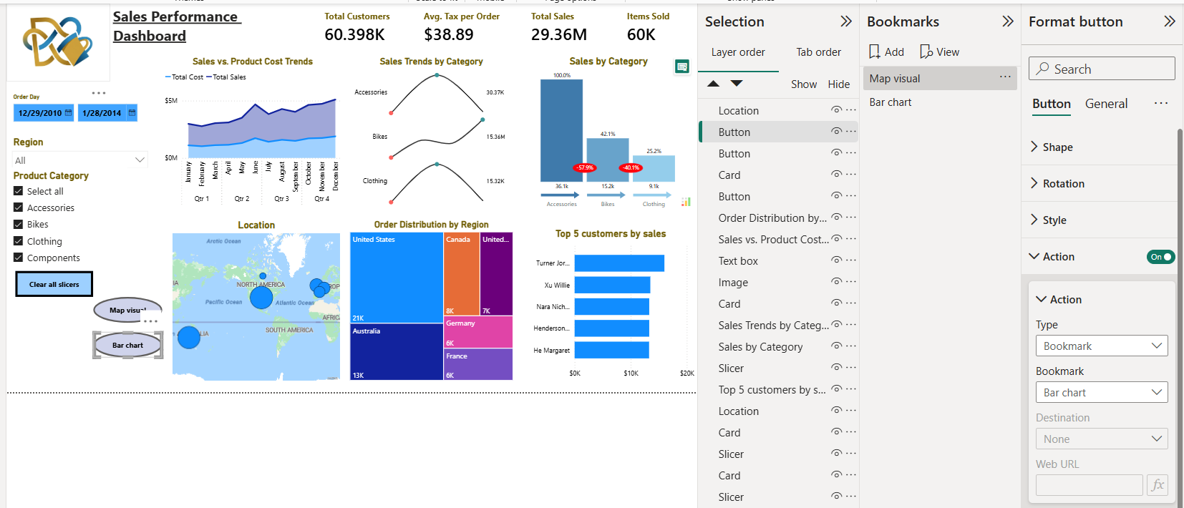
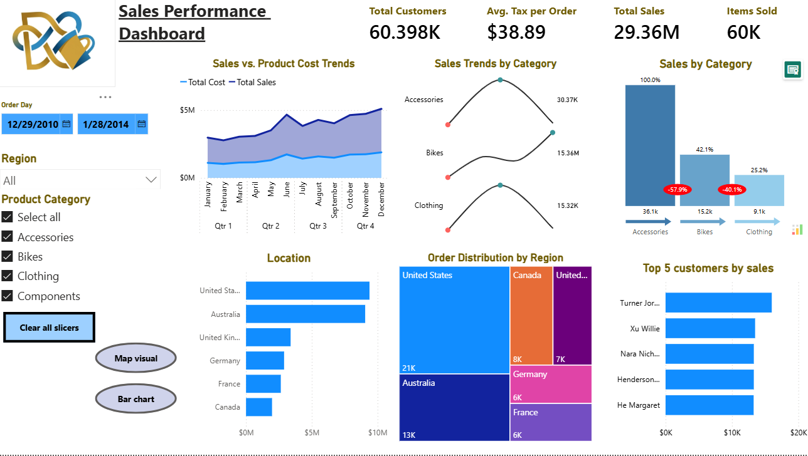
3. To allow users to dynamically toggle between Month-to-Date (MTD), Quarter-to-Date (QTD), and Year-to-Date (YTD) metrics, Field Parameters were utilized. This approach offers a modern, high-performance solution for switching measures dynamically on a single visual.
Compared to traditional methods, Field Parameters provide significant architectural advantages for this requirement:
- Over Bookmarks: Using bookmarks requires creating three overlapping visual layers and managing multiple buttons. This increases maintenance overhead and bloats report complexity. Field Parameters handle the toggle natively within a single visual using a single slicer.
- Over Tabular Editor/Calculation Groups: While Calculation Groups are powerful, they alter the context of all measures in a visual. Field Parameters are much simpler to deploy directly in Power BI Desktop and allow explicit control over exactly which independent measures are exposed to the user.
- Performance Optimization: It minimizes visual rendering times because Power BI only executes the specific DAX measure selected in the slicer, rather than evaluating multiple hidden visual layers.
Before creating the parameter table, two distinct, explicit DAX measures were engineered to handle the underlying time calculations over the standard Total Sales metric ( the measure SalesAmountYTD was created preciously during LAB3):
With the distinct measures established, a dynamic field parameter abstraction layer was generated. Navigating to Modeling -New parameter - Fields, a new parameter table was created. The developed MTD Sales, QTD Sales, and YTD Sales measures were added to the fields list.
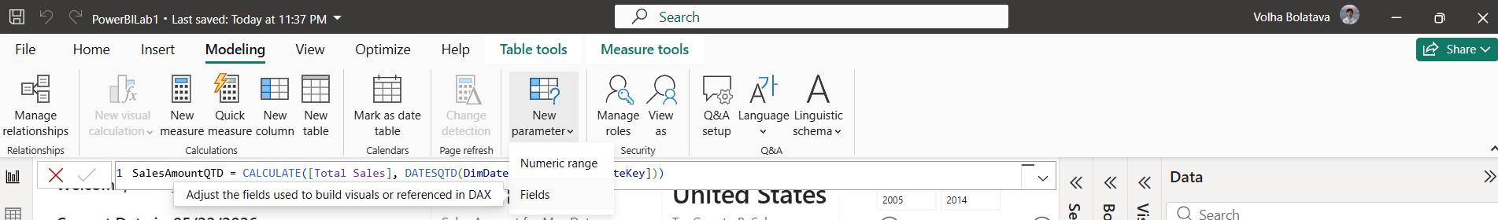
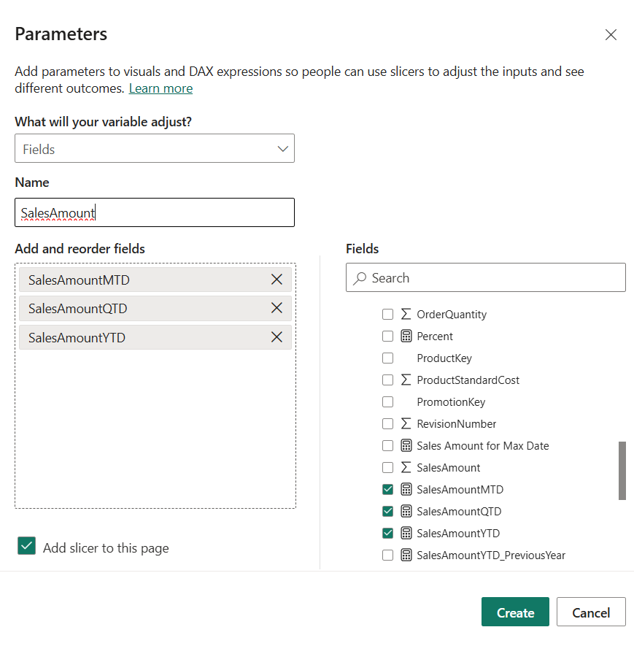
The parameter table acts as the bridge connecting user selection with visual execution. The text field generated by the parameter table was added into a single-select slicer visual on the canvas, rendering clean interactive buttons for MTD Sales, QTD Sales, and YTD Sales. The same parameter field was dragged into the Y-axis bucket of the target dashboard visual “Sales amount Current vs Previous year”:
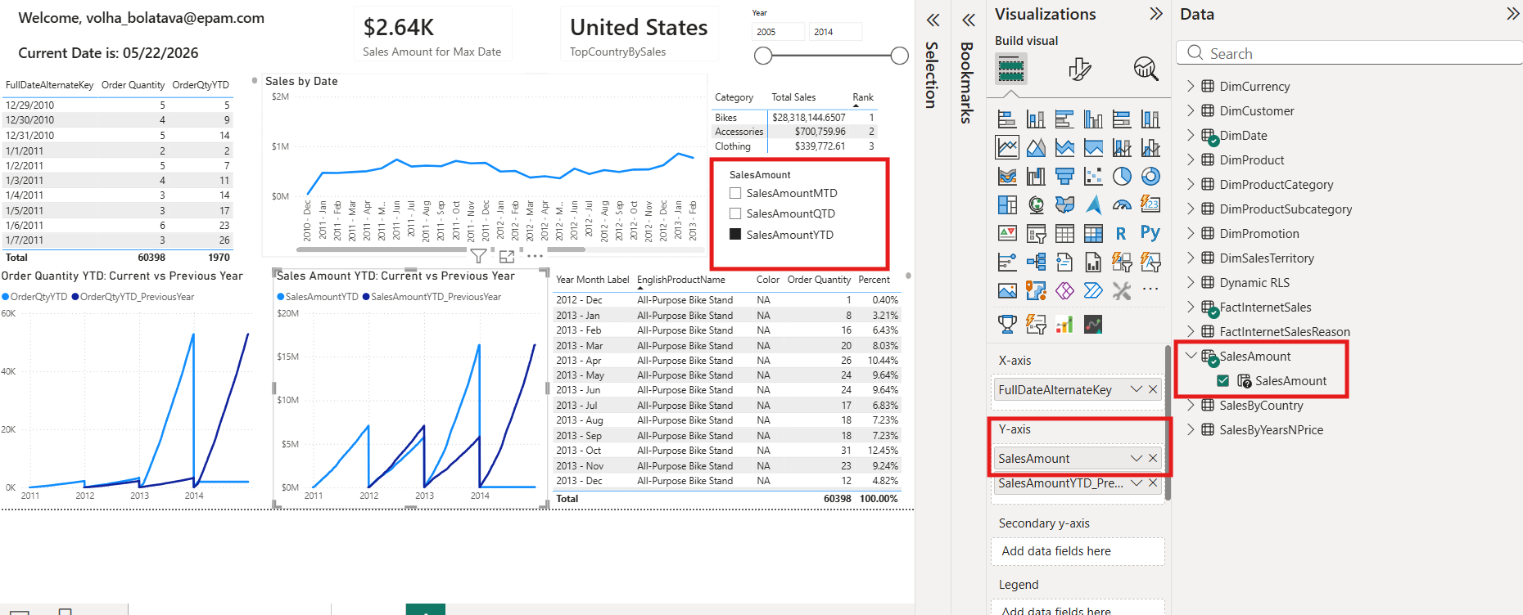
The dynamic integration was validated across the dashboard to ensure flawless context shifting:
- MTD Selection: When the user selects MTD Sales, the line chart instantly scales to display short-term monthly accumulations, validating rapid granularity shifts.
- QTD Selection: Toggling to QTD Sales smoothly recalculates the visualization to track quarterly fiscal baselines.
- YTD Selection: Toggling to YTD Sales aggregates data across the entire year, showing the continuous progressive curve reaching peak performance levels
Throughout this process, all active page slicers (such as Region or Product Category) remain fully applied, proving that the parameter updates the metric definition without destroying user filter context.
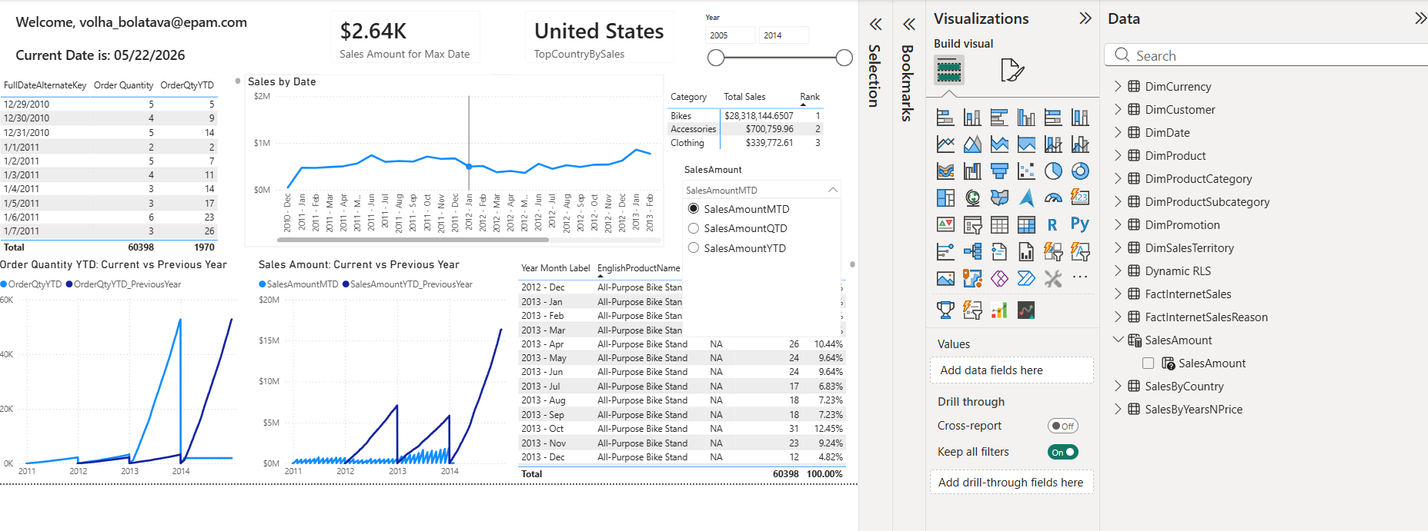
4. To provide corporate users with ad-hoc path exploration and deep root-cause analysis capabilities, a Decomposition Tree visual was integrated into the dashboard. A Decomposition Tree is an advanced, AI-powered visualization in Power BI that breaks down a high-level aggregate metric across multiple explanatory dimensions. Traditional drill-downs force users to follow a rigid, pre-defined hierarchy (e.g., Year $\rightarrow$ Quarter $\rightarrow$ Month). The Decomposition Tree removes this limitation, letting end-users dynamically choose the next analysis path or use built-in AI metrics ("High Value" / "Low Value") to find which attributes contribute most heavily to fluctuations in KPIs.
The visual was configured to analyze Total Sales broken down by three independent operational dimensions: Product Category, Sales Territory Group, and Gender.
These variables were selected because they provide complete horizontal visibility across different business layers:
- Product Category (DimProductCategory): Captures the core inventory driver. It answers what types of products (Bikes, Clothing, Accessories) are moving the baseline figures.
- Sales Territory Group (DimSalesTerritory): Introduces the geographical performance context. It answers where organizational demand is heavily centralized or underperforming.
- Gender (DimCustomer): Represents demographic segmentation from the customer base. It answers who is purchasing, offering granular B2C behavioral insights.
The Decomposition Tree icon was selected from the Visualizations pane.
| 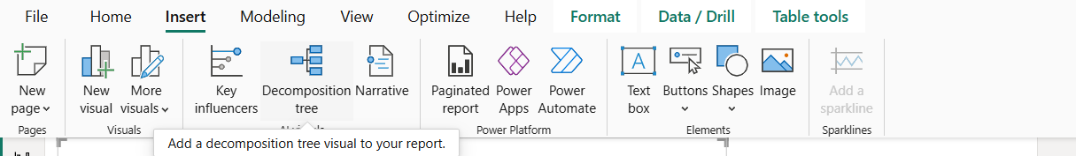
The primary core metric Total Sales was placed into the "Analyze" bucket. The three independent attributes—EnglishProductCategoryName, SalesTerritoryGroup, and Gender—were dragged into the "Explain by" bucket to establish the available branching criteria.
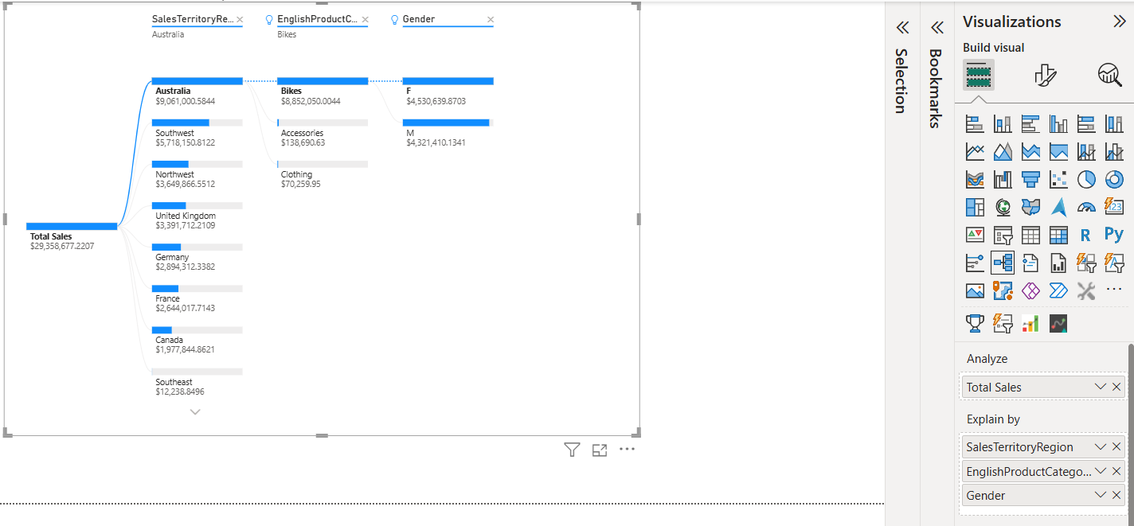
The visuals demonstrate active analysis across multiple user paths, showing how the total revenue pools cascade downwards.This setup transforms static totals into an interactive diagnostic workspace, allowing stakeholders to fluidly break down overall sales metrics along custom paths.
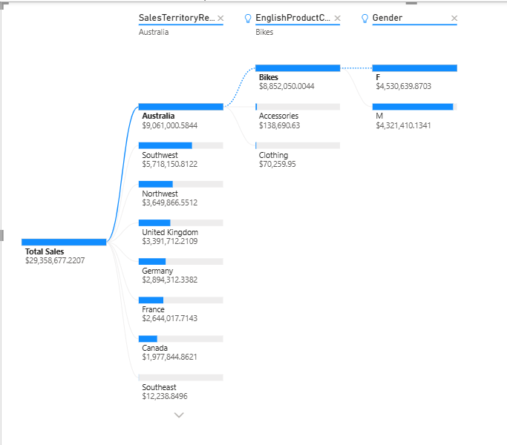
4. To enhance data density and provide context-rich tooltips without cluttering the primary dashboard layout, a specialized Report Page Tooltip was engineered and linked to “Top 5 customers by sales”. A dedicated, hidden tooltip canvas was designed to show a breakdown of Sales by Product Category. Now, when a user hovers over any top customer's name on the dashboard, Power BI dynamically filters the data to display that specific customer's buying preferences, order quantity in total and category spend in a compact pop-up window, providing deeper consumer insights.
A new canvas page named Tooltip was added. In the Format pane under Page settings, the type was explicitly set to Tooltip. Under Page information, the "Allow use as tooltip" toggle switch was turned On.
- 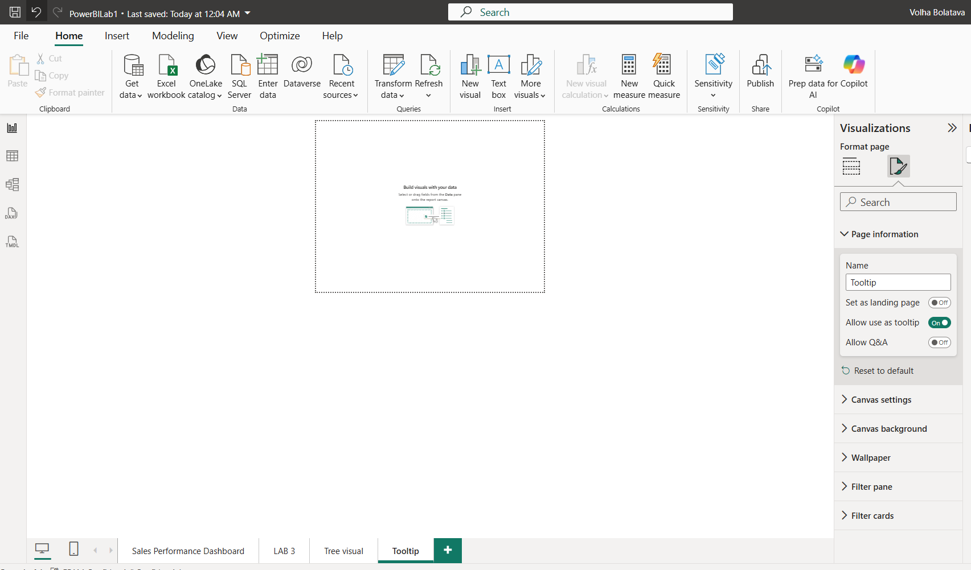
The micro-dashboard canvas was populated with visuals - Bar Chart mapping Total Sales by EnglishProductCategoryName and simple card with order quantity in total:
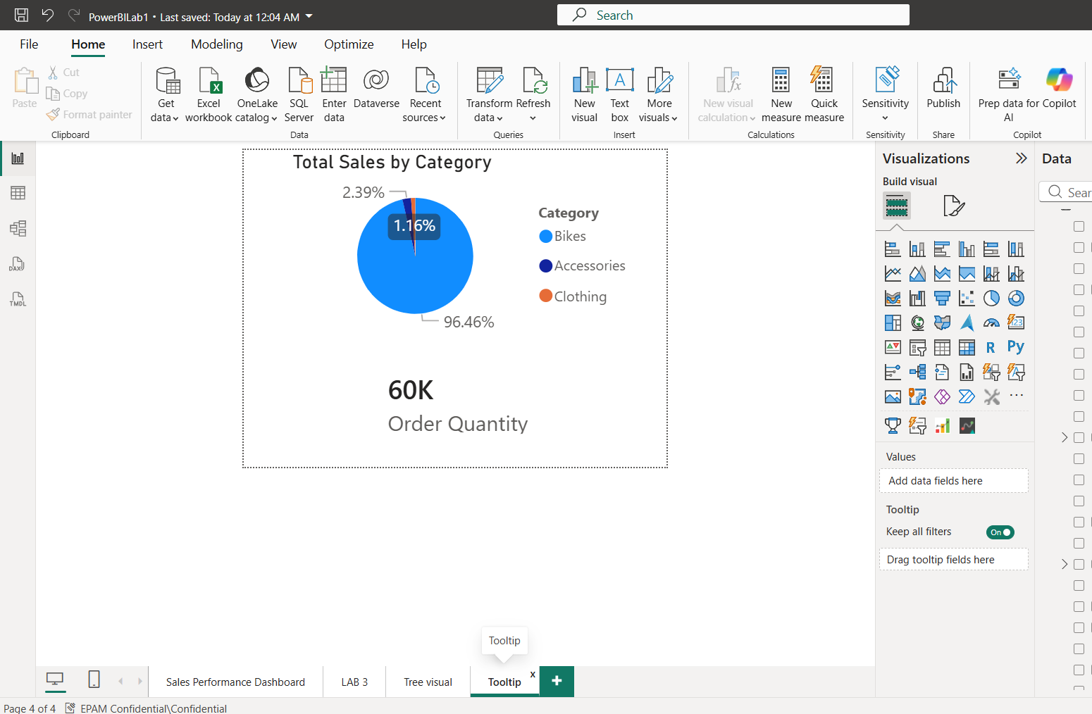
The specialized pop-up page was linked directly to ‘Top 5 customers by sales’ visual:
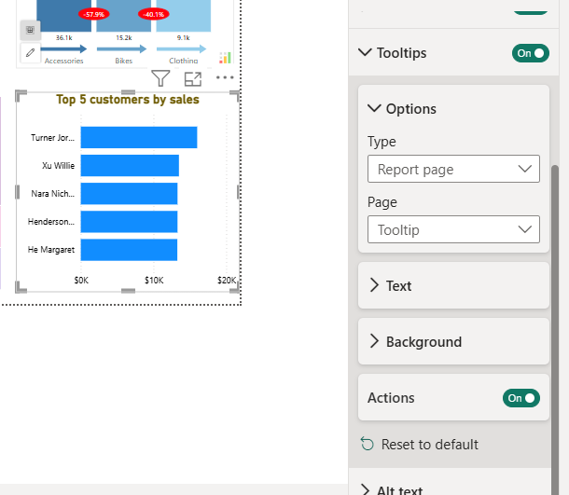
Now instead of a standard textual pop-up showing only raw sales, hovering over any customer bar (e.g., Jordan Turner) instantly passes that specific customer name into the hidden page's filter context. The tooltip automatically recalculates a KPI card to display the customer's total Order Quantity and updates a chart to show their exact Product Category purchase distribution.
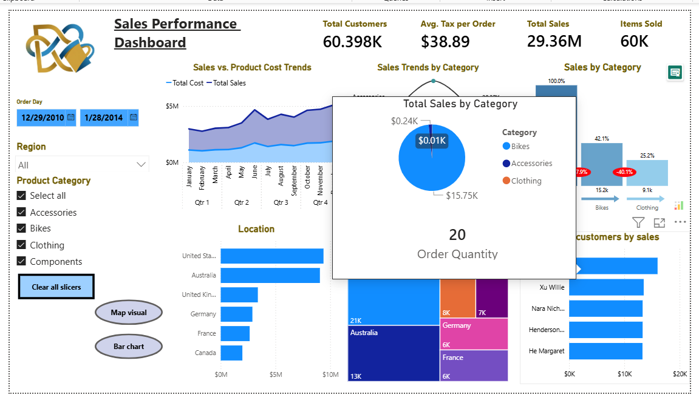
A separate hidden report page was initialized with the page size explicitly configured as a Tooltip, and populated with the KPI card and category breakdown charts. In the primary "Top 5 Customers" visual settings, this page was mapped under General $\rightarrow$ Tooltips. This implementation delivers instant customer behavior audits without navigating away or cluttering the main dashboard canvas.
Following best practices in dashboard design, the dedicated Tooltip canvas page was explicitly hidden from the main report navigation bar. Tooltip pages are designed strictly as auxiliary, contextual overlays meant to be triggered dynamically when a user hovers over data points. If left visible in the main page tabs, users might click on them directly, revealing an empty or awkwardly sized template layout without any active data context. Hiding the page keeps the bottom navigation clean and focused entirely on core report screens.
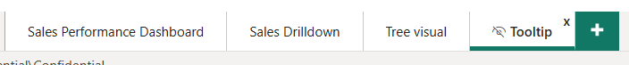

To deliver an intuitive and seamless User Experience (UX), native Navigation Buttons were integrated into the report layout. Buttons were added via the Insert $\rightarrow$ Buttons $\rightarrow$ Blank / Page Navigation pane. Each button was configured using the Action property, where the type was set to Page navigation and mapped to its respective destination canvas.
To empower business users with self-service data exploration, a dedicated Questions (Q&A) action button was implemented on the Sales Drilldown page. Instead of forcing users to build new visuals or search through complex fields for quick answers, the Q&A button provides an intuitive, conversational interface directly inside the dashboard. It acts as a smart shortcut for rapid, ad-hoc decision-making without cluttering the main report real estate:
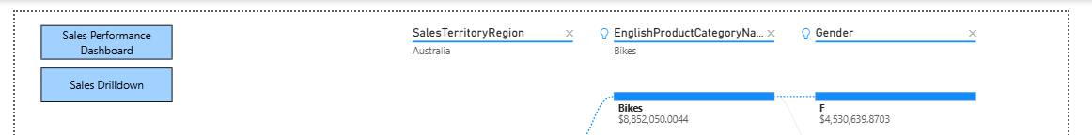
To improve data legibility and accelerate visual auditing within the matrix/table reports, native Conditional Formatting was applied to key performance indicators (Order Quantity and Percent):
Order Quantity: Blue data bars were embedded directly into the column cells. This visualizes the volume distribution instantly, transforming raw numbers into an inline bar chart. It allows stakeholders to immediately spot peak transactional months without reading every individual row.
Percent: A subtle blue gradient color scale was configured for the percentage share column. Darker saturated hues automatically map to higher values, while lighter shades represent lower volumes. This creates an immediate heat map effect that guides the user's eye directly to the most critical business anomalies and successful sales periods.
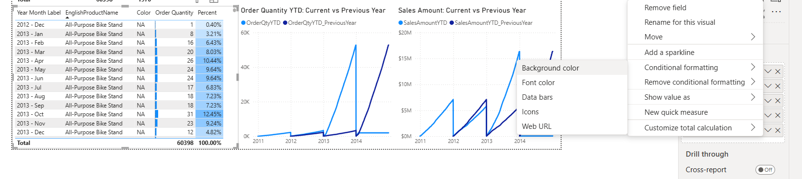
To make the report flexible and easy to maintain, a Data Source Parameter was configured in Power Query. Rather than hardcoding the server address directly into every query, the server name is stored in a single variable called ServerName — acting like a central switch for the entire data connection. If the server path ever changes, only that one parameter value needs to be updated, and all queries in the report automatically point to the new location without touching anything else.
In Power Query Editor, via Manage Parameters → New, a parameter was created with the following settings:
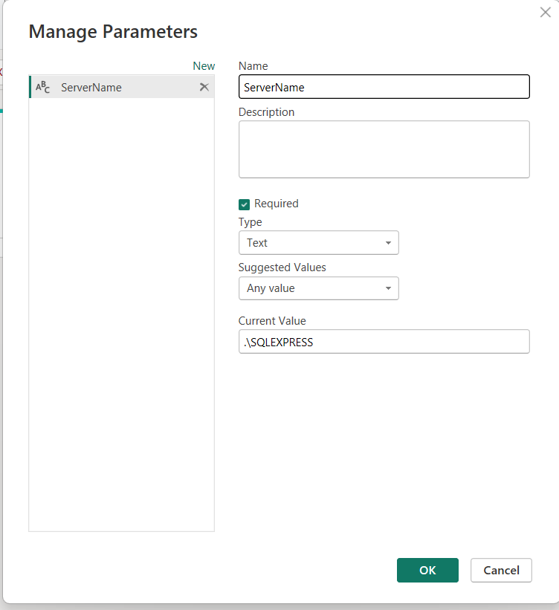
The parameter ServerName was then assigned as the server value in the SQL Server database connection. Instead of a hardcoded address, the Server field now references the ServerName parameter. The formula bar confirms this with = Sql.Databases(".\SQLEXPRESS") being driven by the parameter.

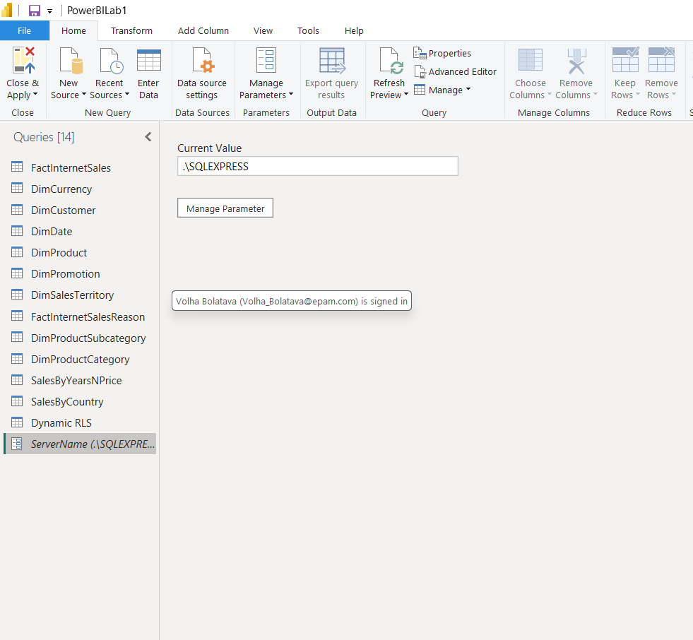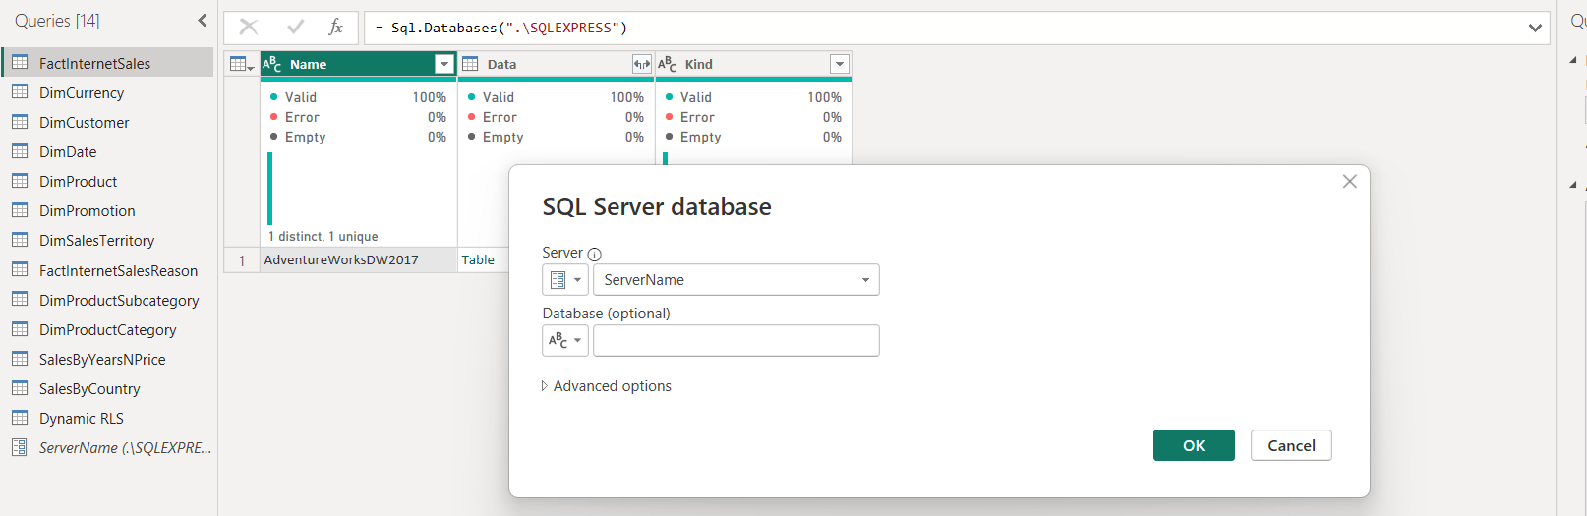
After publishing the report, the parameter became visible and editable in Power BI Service → Settings for PowerBILab1 → Parameters. The ServerName field shows .\SQLEXPRESS and can be updated directly from the browser — no need to open Desktop at all. Anyone who uses this report on a different machine or server simply changes the ServerName value — either in Desktop or directly in the Service — and the entire data model reconnects automatically without touching any queries.
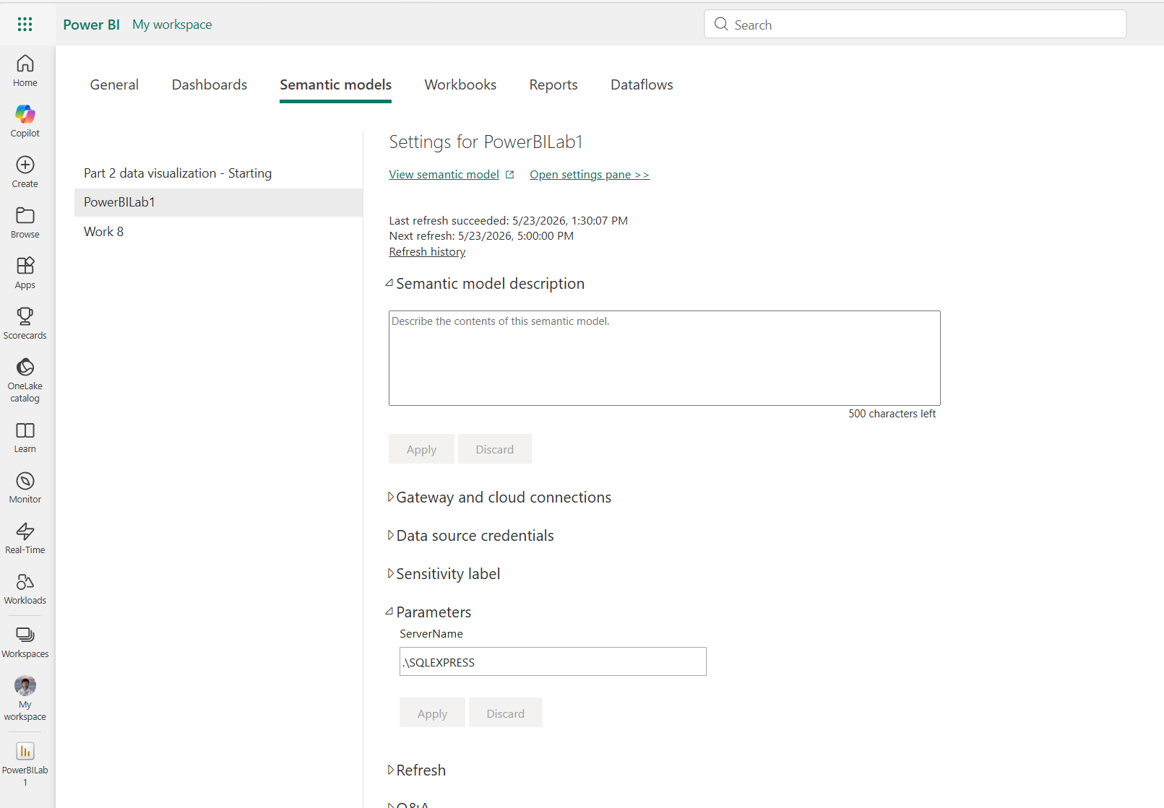
In conclusion, the report successfully elevates this project into a secure, enterprise-grade BI application by integrating all eight Advanced Reporting Concepts: Row-Level Security (RLS) for strict data governance, and Bookmarks & Selections alongside app-like Buttons to deliver a seamless, interactive UI. Furthermore, the deployment of Report Page Tooltips, Field Parameters, and the AI-driven Decomposition Tree maximizes page real estate and enables deep, dynamic ad-hoc analysis. Finally, incorporating inline Conditional Formatting accelerates data scanning, while Data Source Parameters abstract the connection layer to guarantee effortless environment migration between development and production databases.

